Week 11 diary entry

Updates to final project:

1. “Cleaned up” the HTML template
   1. Template was obtained from w3schools <https://www.w3schools.com/w3css/tryw3css_templates_startup.htm>
   2. Contained many elements that I thought were not needed for my data story idea
   3. Commented them out, but did not delete them as the elements may be useful to reference eg. w3-card, style edits
2. Arranged the layout of my data story
   1. Set the sections for the data story
   2. Filled in some of the content
3. Rendered a graph in JavaScript for the data story (IN PROGRESS)
   1. Errors documented below

Work in progress:

1. Finishing the input of content into the HTML
2. Finishing coding of all 4 graphs in JavaScript
3. Finishing coding of button functions

Errors documented (and predicted)

1. Trouble with Chart.js  
   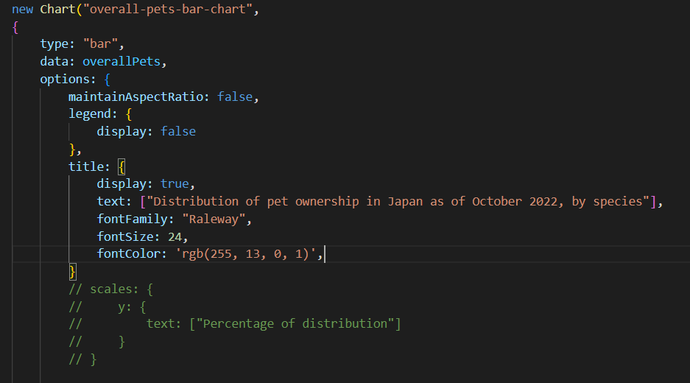
   1. The Chart.js script <script src="https://cdn.jsdelivr.net/npm/chart.js"></script> causes the graph to lose it’s title despite the title being labelled and coded in the JavaScript
   2. For some reason, while trying to add axis labels to the graph, I am unable to use the element “scales”, it just shows an error in the JavaScript
   3. Without chart.js, the regular bar chart does not display all the variables in the x-axis, which is detrimental as I need all the different points to be labelled even though it gives me my title back…  
      Chart, bar chart

      Description automatically generated  
      vs  
      Chart

      Description automatically generated
2. I don’t know how to program the update chart functions to update the chart in the way I want
   1. Specifically for this chart as shown above, I want to change the dataset in the chart such that when I click a button, the number of points in the x-axis changes to show just cats and dogs
   2. I tried to redefine the constants in the updatedata function, but I don’t know how to code it properly to work
   3. I then created a separate graph showing just the cats and dogs, and tried to replace the id of the chart in the html with document.getElementById("canvas-container-1").id = "cats-dogs-bar-chart"; but it didn’t work
   4. Additionally, the event listener for the button in JavaScript doesn’t work either  
      Text

      Description automatically generated  
      I had to add a onclick="updateData()" in the HTML button tag for it to work  
      
   5. I predict that I will face similar problems for the other graphs
3. For my Pet Ownership Trends section, I want have 5 buttons that, when interacted with, change the datasets displayed in the line chart, similar to the chart above, but considering I can’t even get the one above to work I certainly can’t do this one